**Drexler limited slip differential**

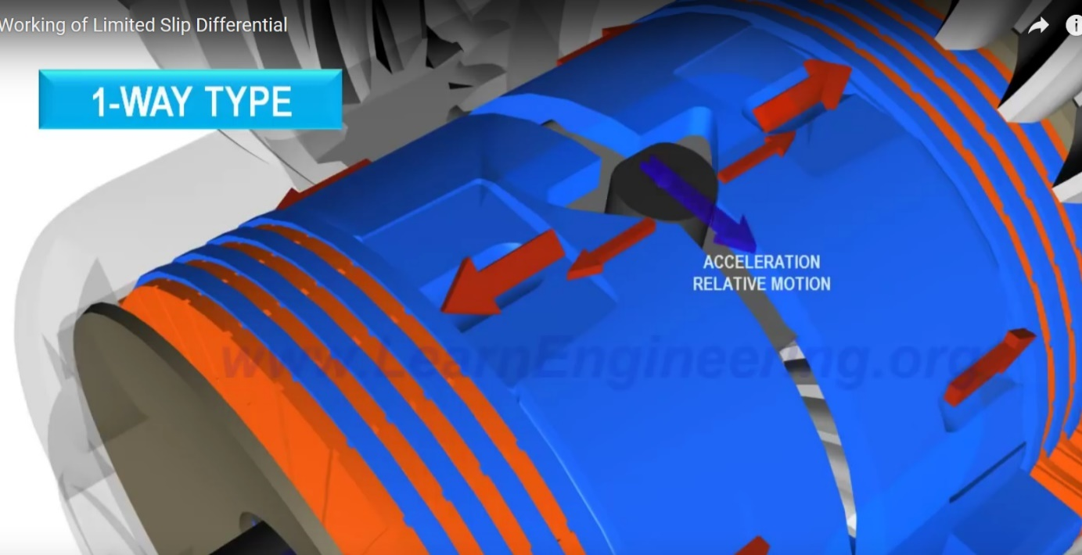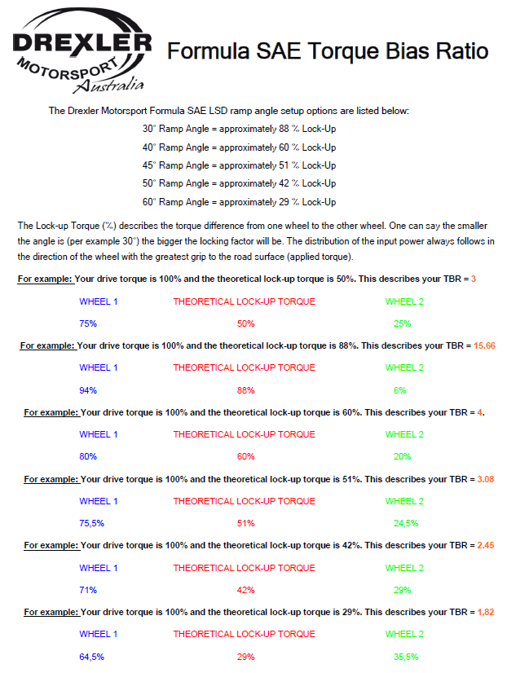

**Efforts on Eccentric carriers**

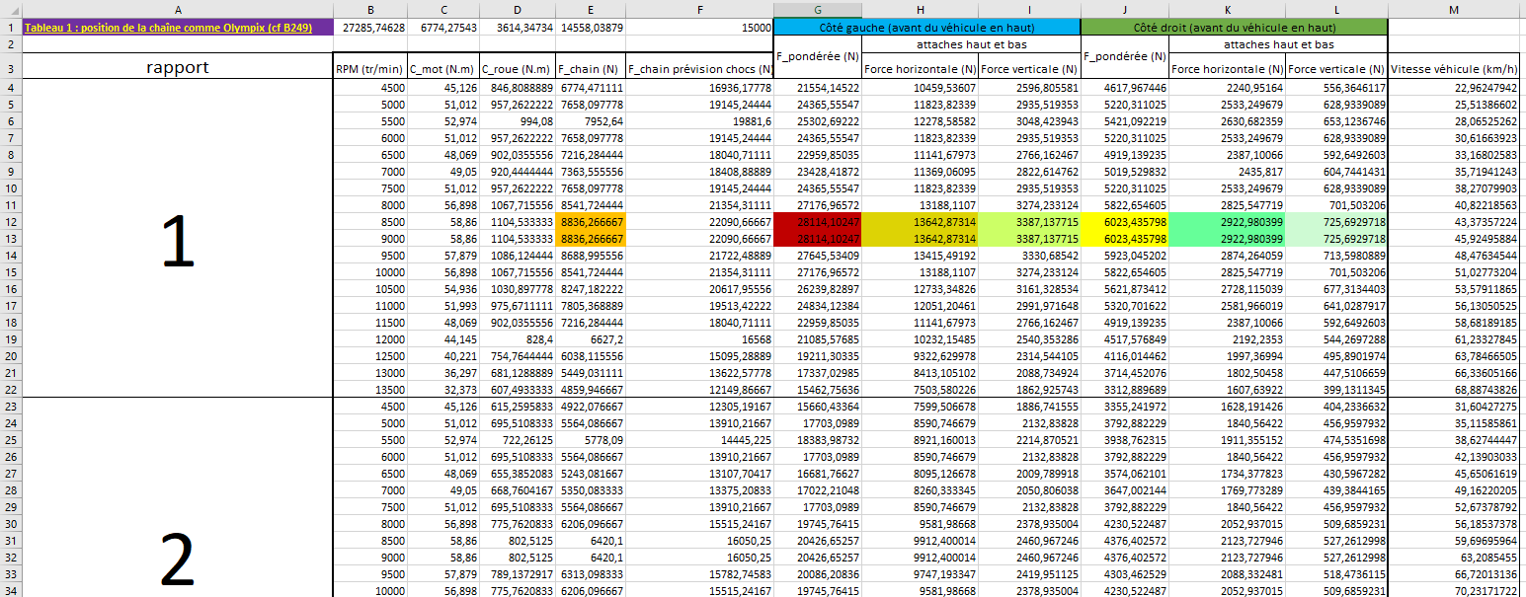

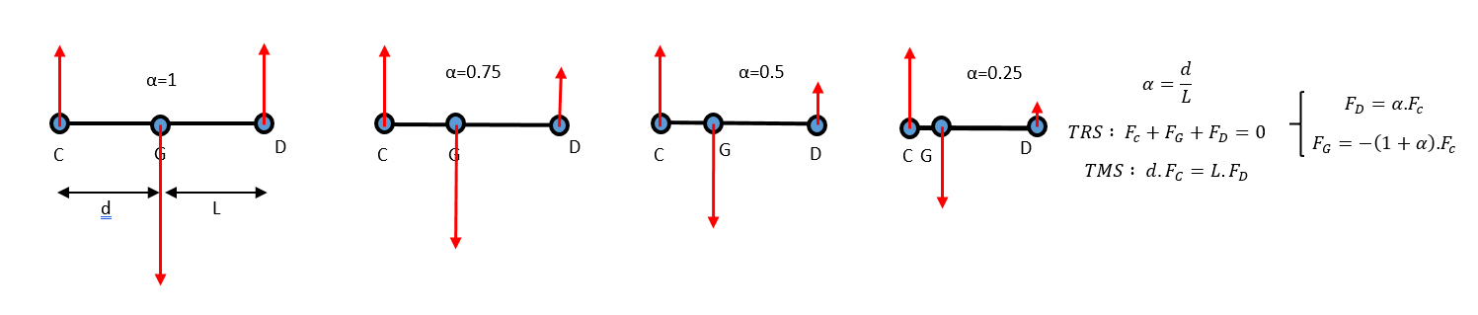

**Finite Elements on left eccentric**

*Material : aluminium 2017 T4*

*Re = 260 MPa*

*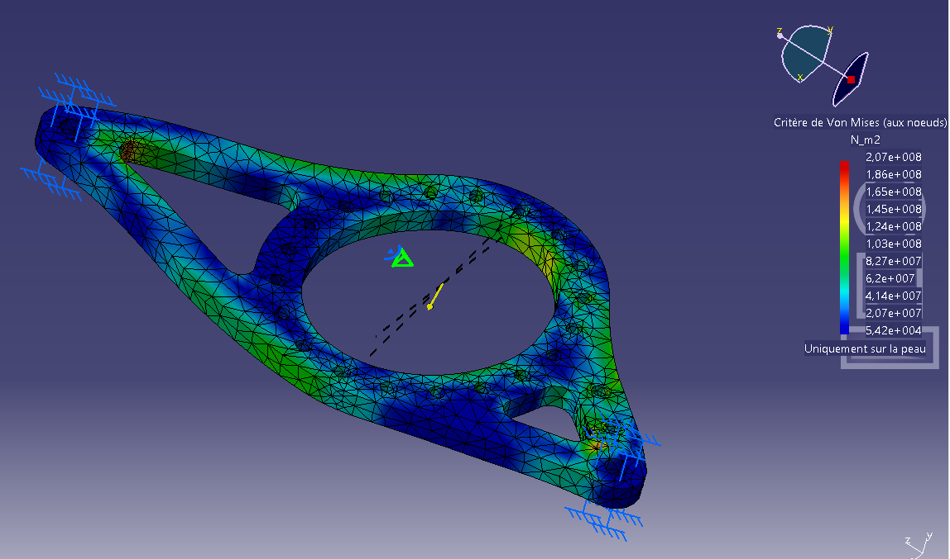Thickness : 14mm*

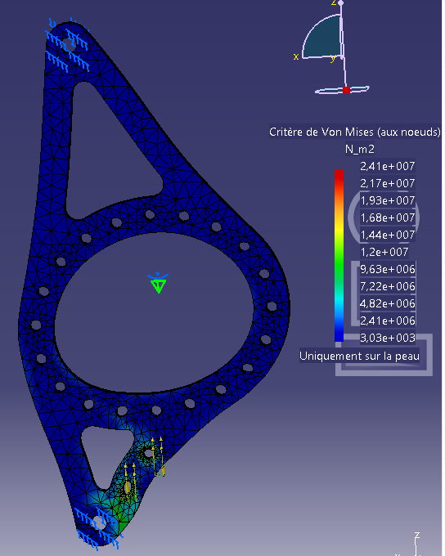

Carrying the car

**Finite Elements on right eccentric**

*Material : aluminium 2017 T4*

*Re = 260 MPa*

*Thickness : 11mm*

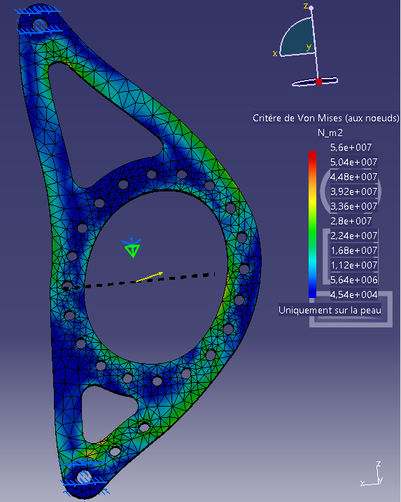

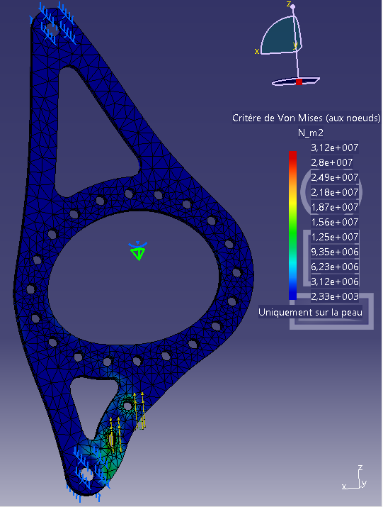

Carrying the car

**Chain tension**

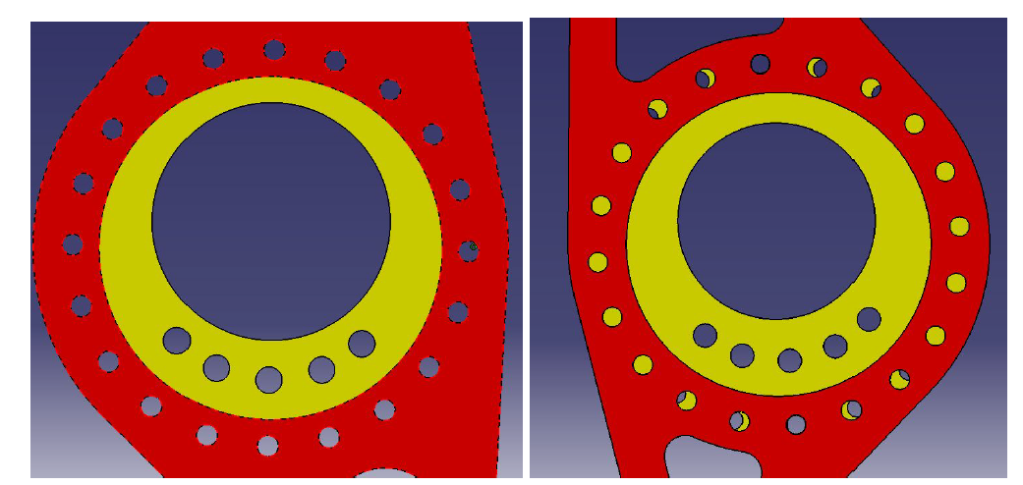

Basic configuration Vulcanix configuration

*Pgcd (fr) = hcf (eng)*

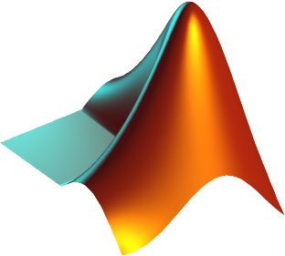**Final Ratio**

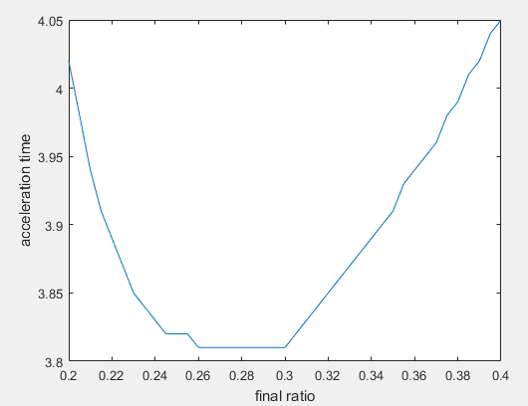

**0.2955**

**FR = 13x44 🡪 0.2955**

**Axle shafts (length calculation)**

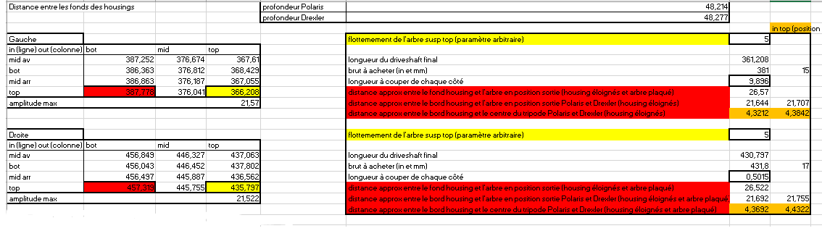

**Axle shafts**

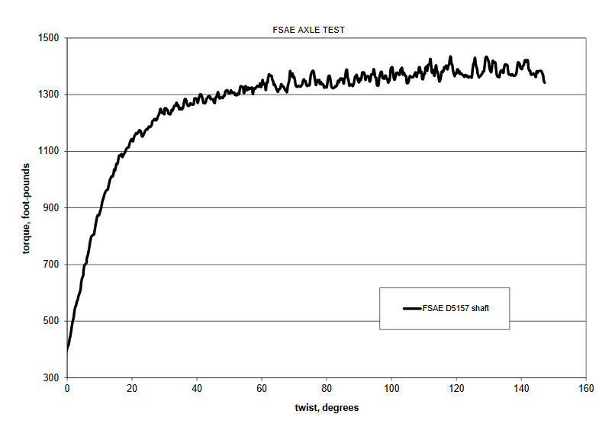

15in (left)

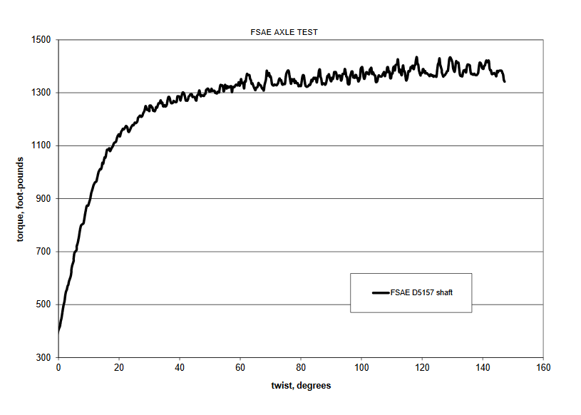

17in (right)

**Left ball bearing (6011-2RS1)**

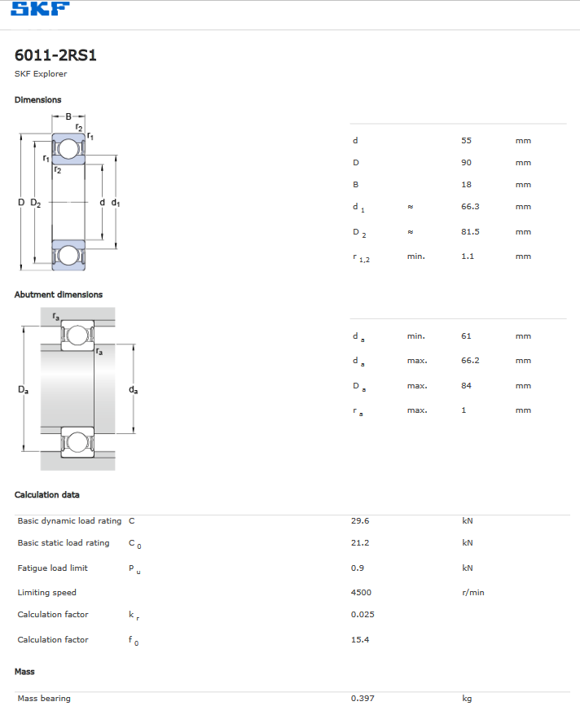

**Right ball bearing (6010-2RS1)**

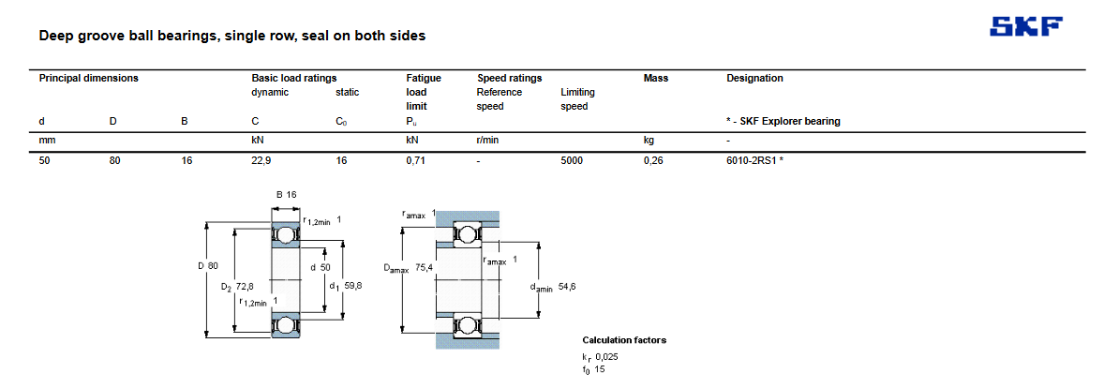

**Sectional view**

